Sound Sensor and Application

20220827 Fang Wenqu

# 1 Theory

Microphone: receive sound and convert it into an electrical signal

Power amplifier: amplify the electrical signal so that it can be detected by the peak detector

Output actuator: converts this amplified electrical signal into a sound signal for listening

# 2 Tasks

## 2.1 Detect Claps

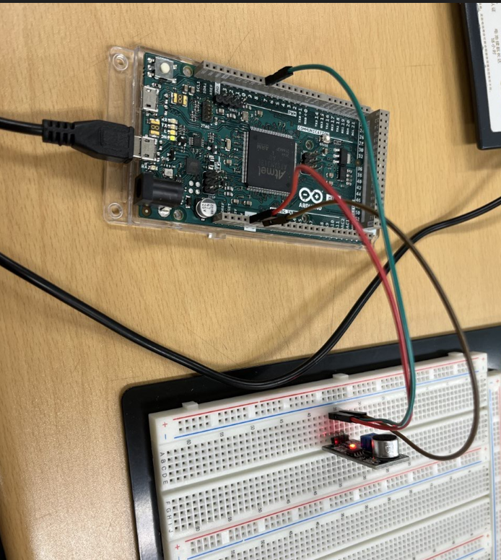

## 2.2 Detect Claps over Background Noise and Signify it with LED

